44.42: a) The dimensions of are energy times time, the dimensions of G are energy times
time per mass squared, and so the dimensions of 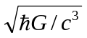are
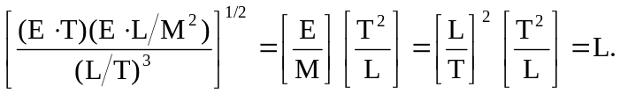
b) 